**Task 2 – Automation**

**GitHub:**

<https://github.com/vonteddukarthikeya/AutomationTask.git>

**Implemented Automation task by using below points:**

1. Used Hybrid approach with modularization (TestNG[TDD], POM, PageFactory)
2. Java language is used to write the scripts ( Descriptive programming , Parameterization)
3. Test data is taken from ( Properties[.properties]  and Excel[.xlsx] files
4. Along with TestNG report, generating Custom/Extent Reports
5. Implemented logger files using log4
6. Implemented Listeners [Success, Failure, Retry Screenshots]
7. Implemented Excel Read and Write concept
8. Browser Compatibility
9. Implemented Parallel execution

**Easy to validate my test [Information]:**

1. To check the Extent/Custom report click - WebTesting.AutomationTask.Extent_Reports
2. To check the logger file - log4jfile.out
3. To check the TestNG reports click - emailable-report.html, index.html
4. Excel Test data - WebTesting.AutomationTask.TestData
5. Success Screenshots - WebTesting.AutomationTask.Success_ScreenShots
6. Failure Screenshots - WebTesting.AutomationTask.Failure_ScreenShots
7. Properties are stored in - absaTest.properties
8. Dependencies are in - pom.xml
9. To run in multiple browsers, please remove the comment in "batchrun.xml" file and make sure all the browsers are available in running system so that execution will not fail.
10. Extent reports code in (ExtentManager.java,ReportsConfig.xml) - this can be used for any applications
11. Excel Read and Write code in (ExcelAPI.java) - this can be used for any applications
12. Test Suite in [batchrun.xml]

**Screenshot’s**

1. **Automation Task - Folder Structure**

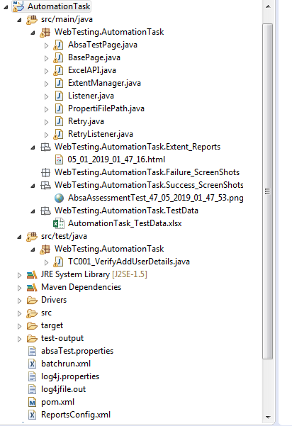

1. **Extent Report Screen Shots**

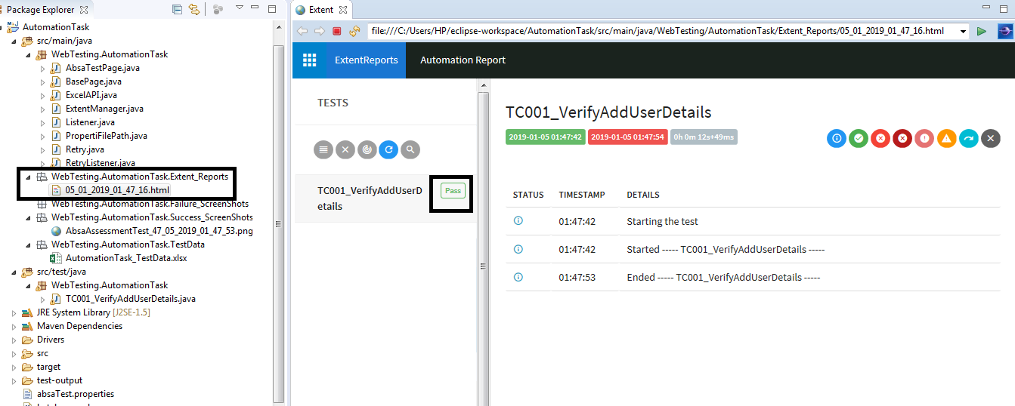

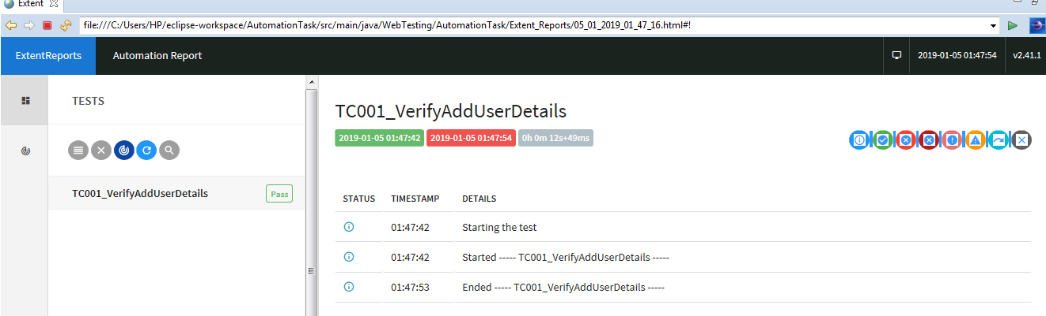

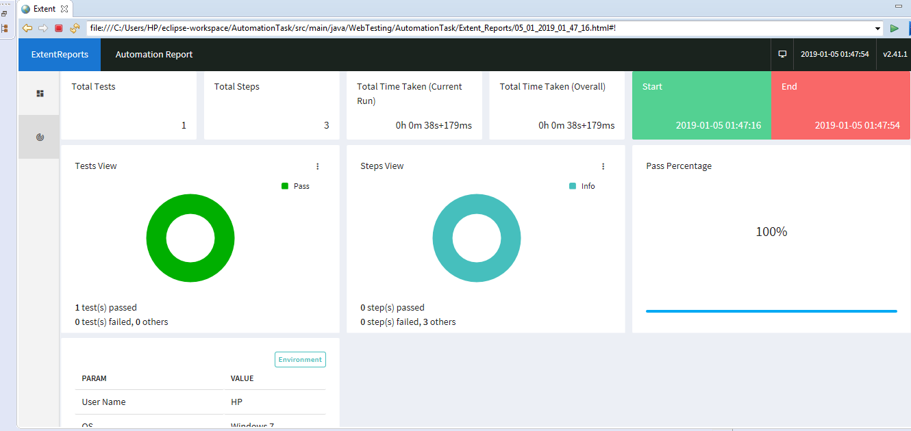

1. **TestNG Reports**

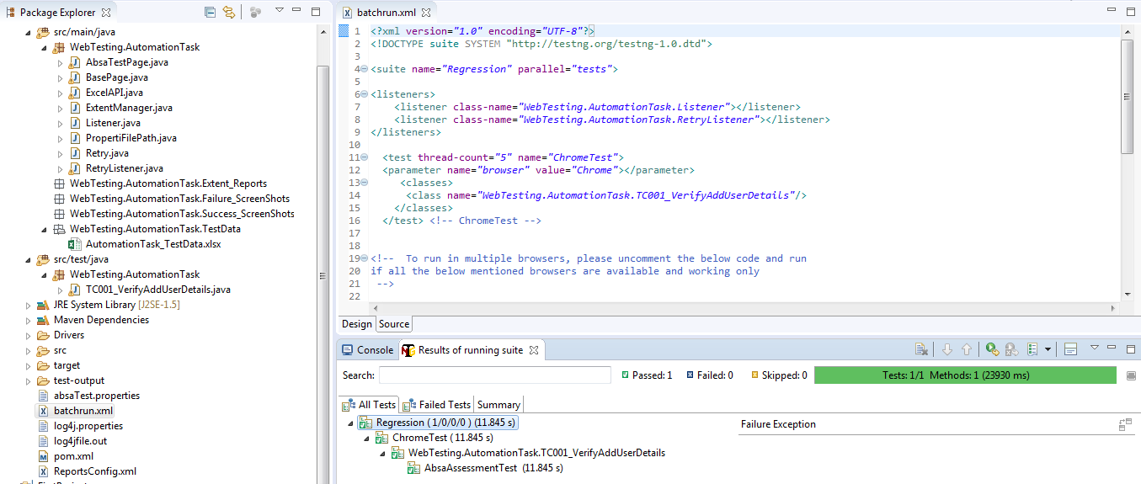

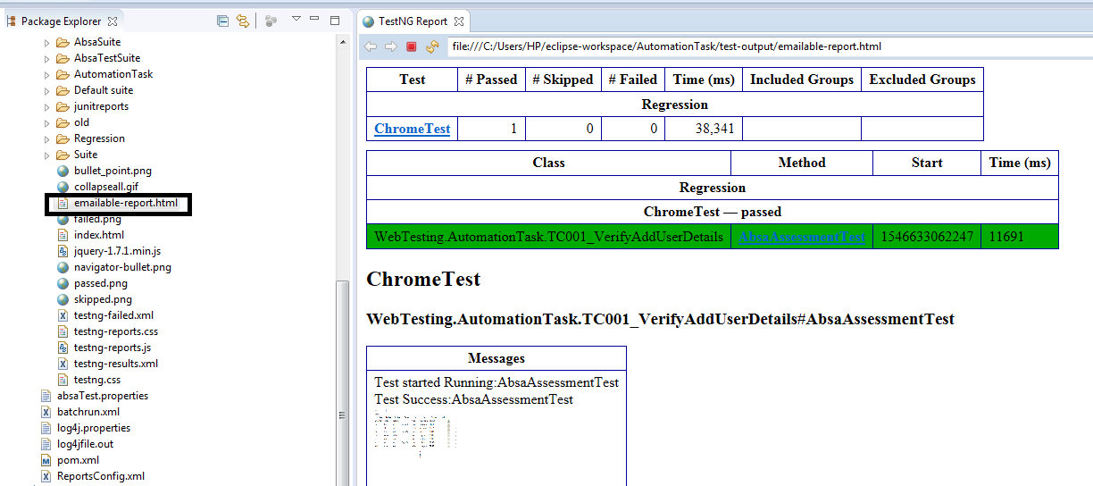

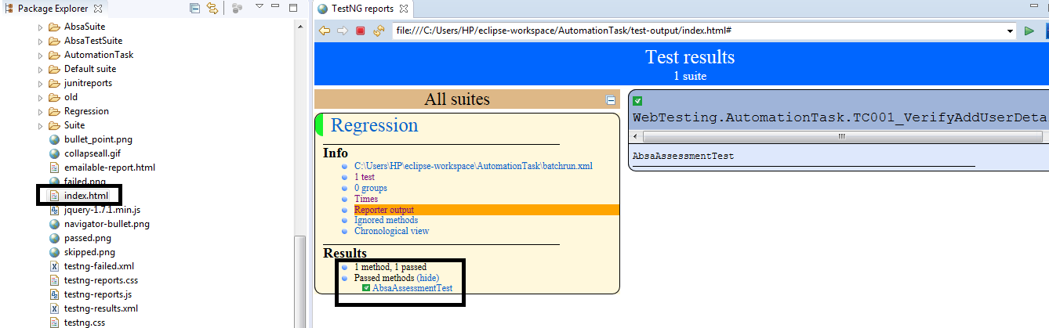

1. **Success Screenshot**

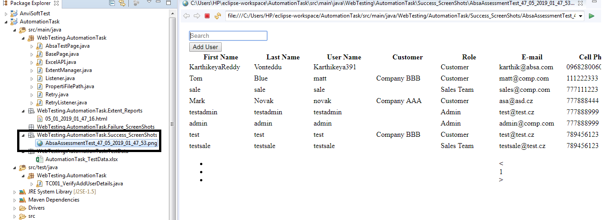

1. **Excel Test Data**

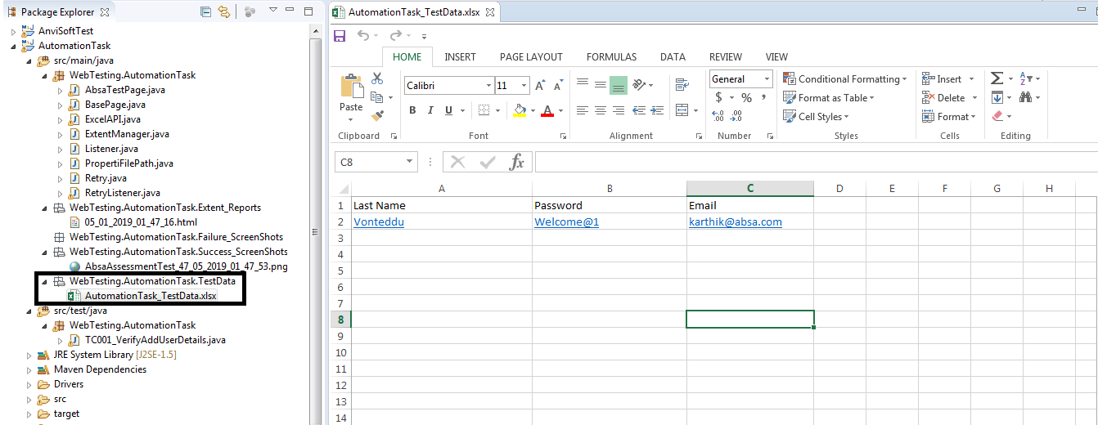

1. **TestNG class code**

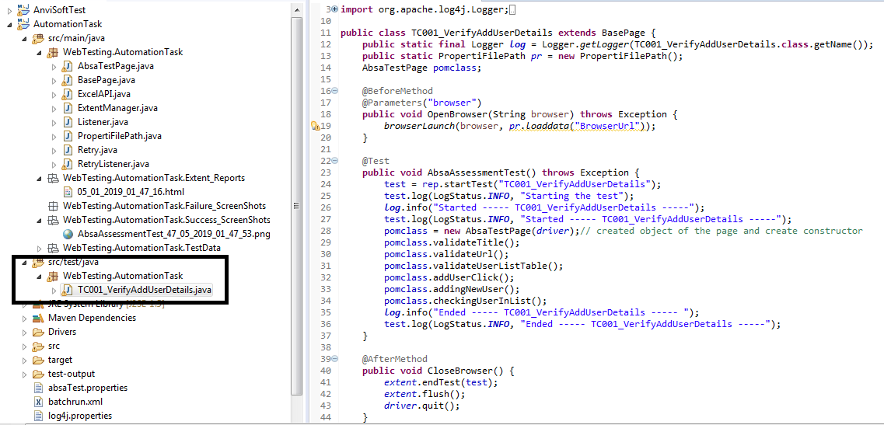

1. **Drivers**

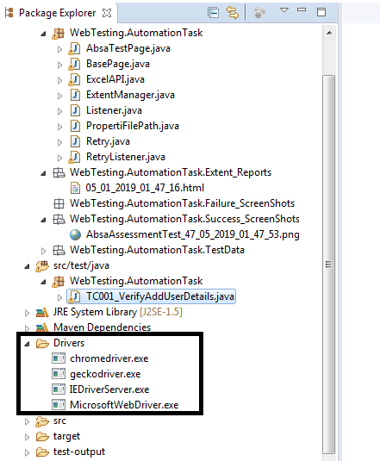

1. **Log4j Properties file**

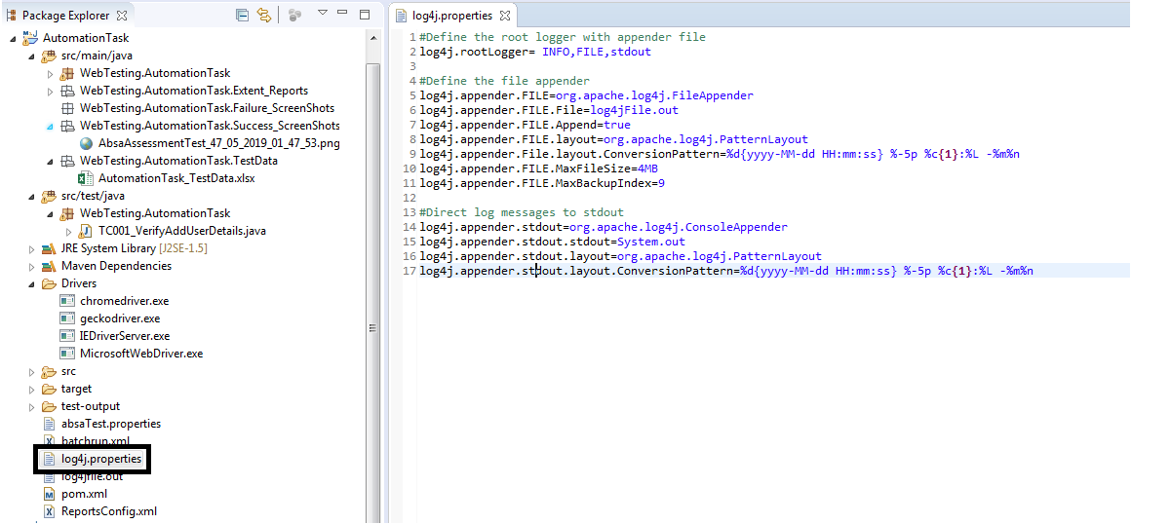

1. **Test Data Properties file**

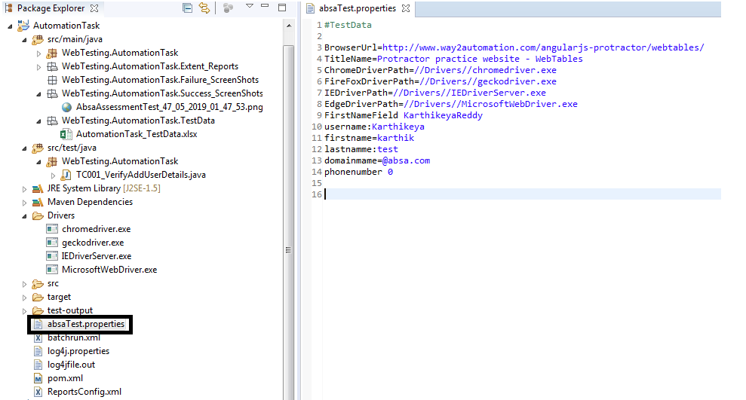

1. **Logger Output file**

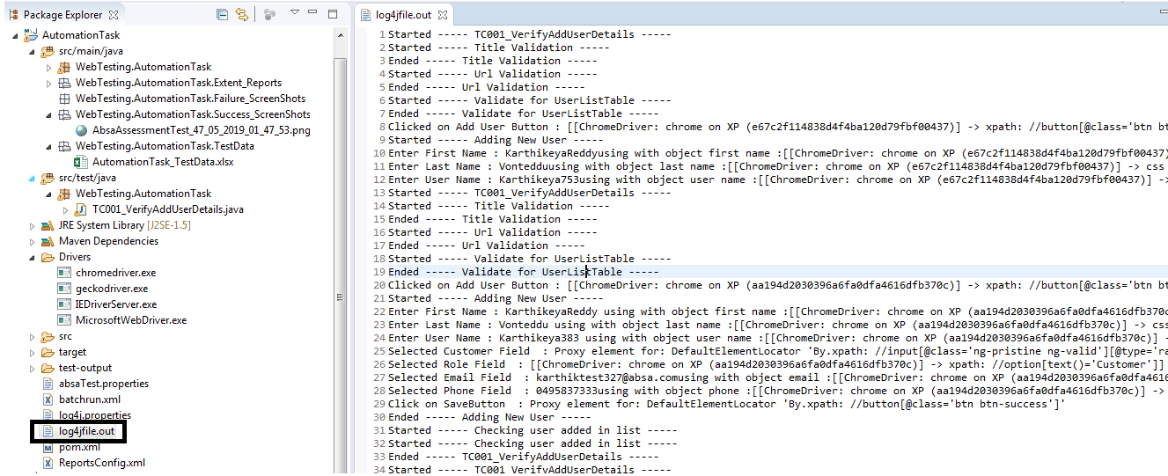

1. **Pom.xml**

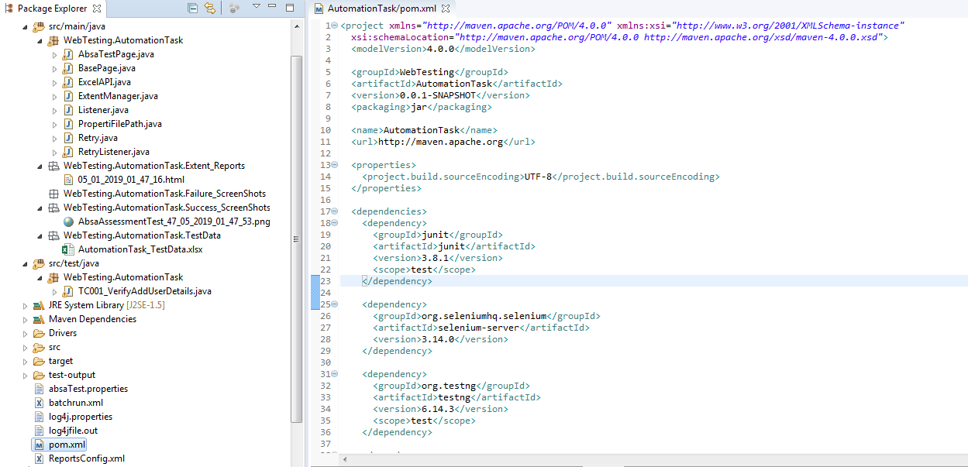

1. **Test Suite [batchrun.xml]**

